FBXW7 (R479L)
Catalog Number:CR-M 26347
Gene Symbol: FBW6; FBW7; FBXW7; FBX30; CDC4; SEL10
Description: Anti-FBXW7 (R479L) Mouse Monoclonal Antibody

Background: F-box/WD repeat-containing protein 7 is a protein that in humans is encoded by the FBXW7 gene. The F-box proteins constitute one of the four subunits of ubiquitin protein ligase complex called SCFs (SKP1-cullin-F-box), which function in phosphorylation-dependent ubiquitination. Mutations in this gene are detected in ovarian, breast and colorectal cancer cell lines, implicating the gene's potential role in the pathogenesis of human cancers.
Immunogen: A synthetic peptide from the internal region of FBXW7 which includes the mutation of R479L, human origin.
Tested applications: ELISA, WB
Recommended dilutions:
ELISA: 1:1000-1:5000
WB: 1:500-1:1000
Concentration: 1 mg/ml
Host: Mouse
Clonality: Monoclonal
Purity: Purified from ascites
Format: Liquid
Storage buffer:
Preservative: no
Constituents: PBS (without Mg²⁺ and Ca²⁺), pH 7.4, 150 mM NaCl, 50% glycerol
Species Reactivity: Recognizes R479L mutant, but not wild-type FBXW7 of vertebrates.
Storage Conditions: Store at -20°C. Avoid
freeze / thaw cycles

Western blot:
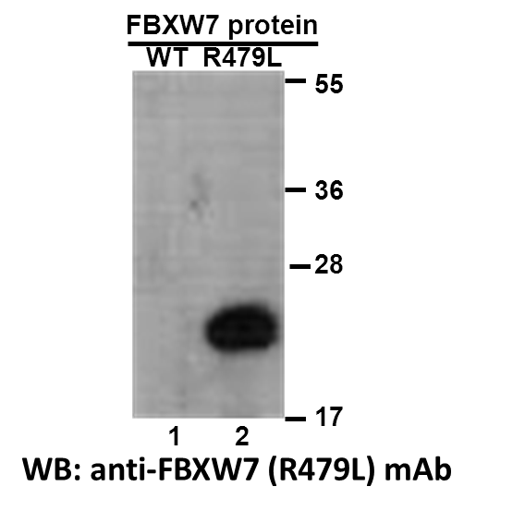
Western blot analysis of recombinant FBXW7 (R479L) and wildtype proteins. Purified His-tagged FBXW7 (R479L) protein (lane 2) and corresponding wildtype protein (lane 1) were blotted with anti-FBXW7 (R479L) monoclonal antibody (Cat. #26347).

科博瑞（武汉）生物科技有限公司
TEL：027-87615885 15972062685
- mail：3636901710@qq.com
Web:www.coburybio.com

